**TASK 02: Lab Rescheduling Management System  
BANDARA H.G.T.D.  
2022/E/048  
2025/06/09**

**1. High Level Problem Summary**

Efficient and conflict-free lab session rescheduling is not possible with the current manual and fragmented process, resulting in communication lapses, scheduling errors, and administrative inefficiencies.  
Success will be measured by the implementation of a digital system that enables students to request lab rescheduling, automates approval workflows, notifies all stakeholders, and maintains a complete log of rescheduling activities.  
The project scope includes:

* User management for students, subject coordinators, and lab instructors
* Digital request and approval workflow
* Automated email notifications
* Lab schedule and availability tracking
* Reporting and logs for lab usage and rescheduling history  
  Out of scope:
* Creation of the initial lab timetable
* Physical lab infrastructure management
* Integration with financial or academic calendar systems

**2. Detailed Problem Statement**

**2.1 FUNCTION**

The solution must:

* Allow students to submit lab rescheduling requests with supporting documents (e.g., faculty approval letter)
* Enable subject coordinators to review and approve/reject requests, and forward approved requests to lab instructors
* Notify all relevant parties (students, coordinators, instructors) via email about request status and schedule changes
* Track lab details (Lab ID, Name, Location, availability) and update schedules accordingly
* Record attendance for rescheduled sessions
* Generate reports on lab usage and rescheduling trends

Key features (in order of priority):

* Secure login for different user roles
* Request submission and approval workflow
* Automated notifications
* Schedule management and conflict checking
* Reporting and audit logs

**2.2 TIME**

Past:  
Lab rescheduling was handled manually using paper forms, emails, or phone calls, often leading to lost requests, delayed approvals, and scheduling conflicts.

Present:  
The new system will be used by students needing to reschedule labs, subject coordinators managing requests, and lab instructors updating schedules and attendance. It addresses the need for a centralized, efficient, and transparent process.

Future:  
Potential extensions include integration with academic management systems, mobile app access, predictive analytics for lab utilization, and expansion to cover equipment booking and maintenance scheduling.

**3. Key Stakeholders**

* Students: Submit rescheduling requests and receive notifications
* Subject Coordinators: Approve/reject and manage requests
* Lab Instructors: Confirm reschedules and update attendance
* Academic Administration: Review reports and ensure policy compliance
* IT Support: Maintain and update the system

**4. Revision History**

|  |  |  |  |
| --- | --- | --- | --- |
| Version | Date | Author | Description |
| 1.0 | 2025/05/01 | BANDARA H.G.T.D. | Initial problem statement created |
| 1.1 | 2025/06/01 | BANDARA H.G.T.D. | ER diagram completed and reviewed |

Project Timeline & Milestones

* 2025/05/01: Project initiated, requirements gathering started
* 2025/05/10: Completed user role and workflow analysis
* 2025/05/20: Drafted system features and use cases
* 2025/06/01: ER diagram completed

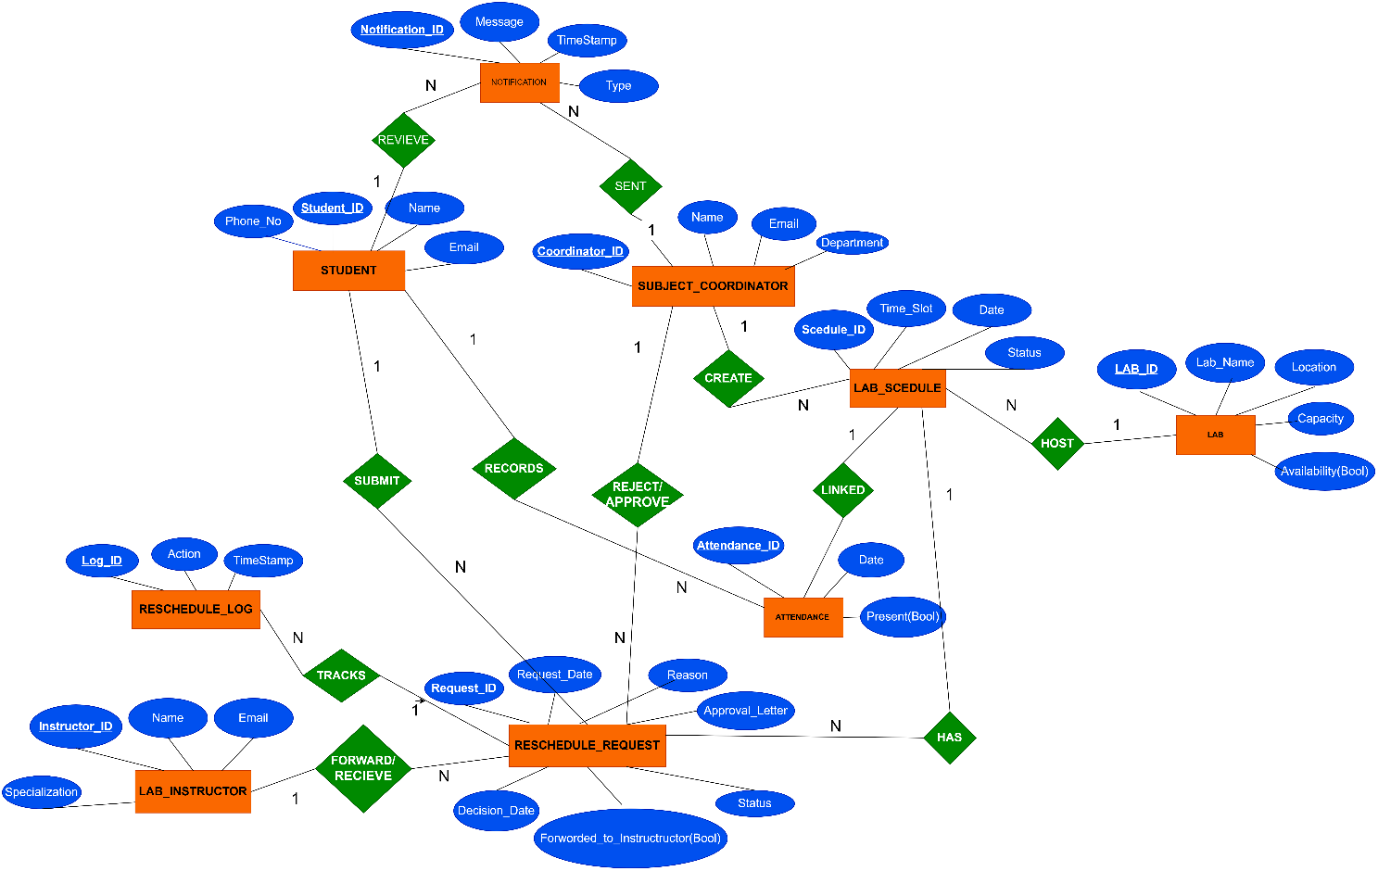

**FIGURE 01: ER DIAGRAM IN VERSION (V1.1)**

**TASK 2.1**: Data collection or created or a combination related to the project.

|  |  |  |  |
| --- | --- | --- | --- |
| **STUDENTS** |  |  |  |
| **StudentID** | **Name** | **Email** | **Phone** |
| S001 | Asha Singh | asha@univ.edu | 9876543210 |
| S002 | Ravi Kumar | ravi@univ.edu | 9123456789 |

|  |  |  |  |
| --- | --- | --- | --- |
| **SUBJECT COORDINATORS** | |  |  |
| **CoordinatorID** | **Name** | **Email** | **Department** |
| C001 | Dr. Meera | meera@univ.edu | Computer Sci |

|  |  |  |  |
| --- | --- | --- | --- |
| **LAB INSTRUCTORS** | |  |  |
| **InstructorID** | **Name** | **Email** | **Specialization** |
| L001 | Mr. Joseph | joseph@univ.edu | Networking |

|  |  |  |  |  |
| --- | --- | --- | --- | --- |
| **LABS** |  |  |  |  |
| **LabID** | **LabName** | **Location** | **Capacity** | **Availability** |
| LB01 | Computer Lab 1 | Block A | 30 | TRUE |

|  |  |  |  |  |  |
| --- | --- | --- | --- | --- | --- |
| **LAB SCHEDULES** |  |  |  |  |  |
| **ScheduleID** | **LabID** | **CoordinatorID** | **TimeSlot** | **Date** | **Status** |
| SCH01 | LB01 | C001 | 10:00-12:00 | 6/10/2025 | Scheduled |

|  |  |  |  |  |  |  |  |  |
| --- | --- | --- | --- | --- | --- | --- | --- | --- |
| **RESCHEDULE REQUESTS** | | |  |  |  |  |  |  |
| **Request ID** | **Student ID** | **Schedule ID** | **Request Date** | **Reason** | **Approval Letter** | **Status** | **Forwarded ToInstructor** | **Decision Date** |
| RQ001 | S001 | SCH01 | 6/5/2025 | Medical reason | [file] | Pending | FALSE | NULL |

|  |  |  |  |  |  |
| --- | --- | --- | --- | --- | --- |
| **NOTIFICATIONS** | |  |  |  |  |
| **NotificationID** | **Message** | **Timestamp** | **Type** | **StudentID** | **CoordinatorID** |
| N001 | Your reschedule is approved. | 6/6/2025 9:00 | Email | S001 | C001 |

|  |  |  |  |  |
| --- | --- | --- | --- | --- |
| **ATTENDANCE** | |  |  |  |
| **AttendanceID** | **StudentID** | **ScheduleID** | **Date** | **Present** |
| A001 | S001 | SCH01 | 6/10/2025 | TRUE |

|  |  |  |  |
| --- | --- | --- | --- |
| **RESCHEDULE LOG** | | |  |
| **LogID** | **RequestID** | **Action** | **Timestamp** |
| LOG01 | RQ001 | Submitted | 6/5/2025 8:00 |

* 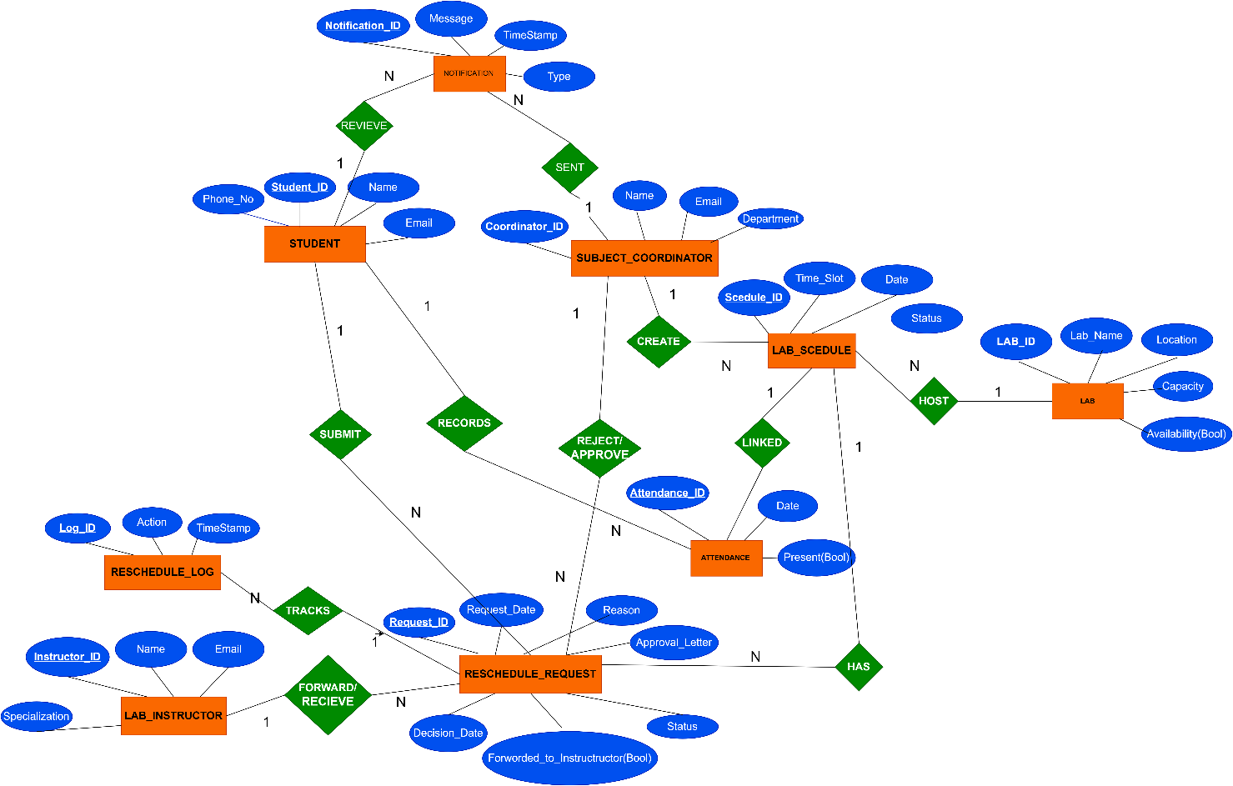**TASK 2.2**: THE REVISED ER DIAGRAM

**FIGURE 02: THE REVISED ER DIAGRAM (1.2)**

**TASK 2.3**: TENTATIVE RELATION SCHEMAS

* **Student** (*StudentID PK*, Name, Email, Phone)
* **SubjectCoordinator** (*CoordinatorID PK*, Name, Email, Department)
* **LabInstructor** (*InstructorID PK*, Name, Email, Specialization)
* **Lab** (*LabID PK*, LabName, Location, Capacity, Availability)
* **LabSchedule** (*ScheduleID PK*, LabID FK, CoordinatorID FK, TimeSlot, Date, Status)
* **RescheduleRequest** (*RequestID PK*, StudentID FK, ScheduleID FK, RequestDate, Reason, ApprovalLetter, Status, ForwardedToInstructor, DecisionDate)
* **Notification** (*NotificationID PK*, Message, Timestamp, Type, StudentID FK, CoordinatorID FK)
* **Attendance** (*AttendanceID PK*, StudentID FK, ScheduleID FK, Date, Present)
* **RescheduleLog** (*LogID PK*, RequestID FK, Action, Timestamp)

Note: PK:- Primary Key, FK:- Foreign Key

**TASK 2.4: THE QUERIES FOR CREATING THE DATABASE**

**FIGURE 03: QUERY FOR CREATING THE DATABASE**

**FIGURE 04: THE QUERIES FOR CREATING THE TABLES**

**FIGURE 05: QUERIES FOR ADDING SHOWED DATA IN TO THE DATABASE**

**AFTER ADDING SAMPLE DATA INTO THE DATABASE TABLES**

**STUDENTS**

**SUBJEC TCOORDINATOR**



**LAB INSTRUCTORS**



**LABS**



**LAB_SHEDULES**



**RESCHEDULE REQUESTS**



**NOTIFICATIONS**



**ATTENDANCE**



**RESCHEDULE LOG**

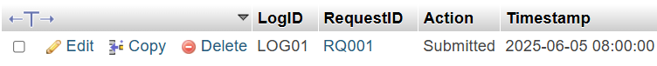

**FIGURE 06: TABLE VIEW AFTER ADDING DATA**

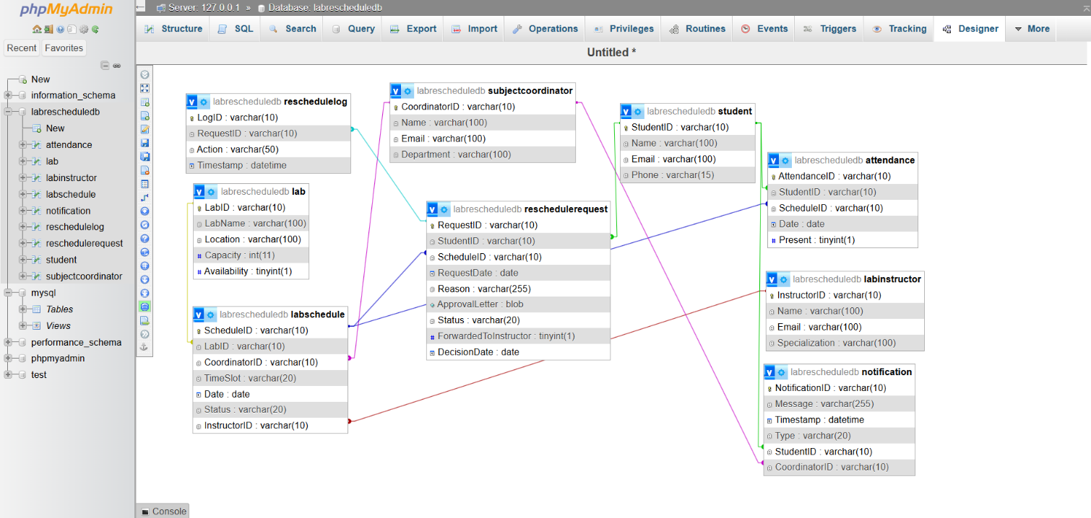

**FIGURE 07: DESIGNER VIEW OF THE DATABASE**